# Design

Our design consists of a two-DOF stacked cartwheel flexure assembly actuated using two voice coils. Knife edge sensors and IMU data are used for control feedback. An angular flexure system is used because moving the flexure through a small angle causes a large linear displacement of the laser dot at the target. A mechanism consisting of only linear displacement flexures would require three degrees of freedom to meet the design requirements; a system based on angular flexures only requires two degrees of freedom, and therefore two actuators, to meet the same requirements. The combination of less axes (less mass) and the lever effect allows for significantly higher bandwidth, compared to linear axes. A schematic of the mechanical design is presented in Figure 1.



Figure 1: Schematic of mechanical assembly

The first flexure is attached to the base and rotates round the x-axis when actuated by  , controlling the vertical position of the laser on the target. The second flexure is rigidly connected to the first and rotates around the z-axis when actuated by , controlling the horizontal position of the laser on the target. The schematic shows the design “unfolded” onto the page – the coordinate systems attached to each flexure show the orientation of each flexure stage. Figure 2 shows an isometric view of the solid model.



Figure 2: Solid model of mechanical design (sensors not shown)

# Design Analysis

A derivation of the natural frequency of an ideal cartwheel mechanism is shown in Figure 3. This applies only to the yaw cartwheel, as the natural frequency of the pitch cartwheel will be lower because it ‘carries’ the yaw cartwheel during its motion. The behavior of the cartwheels is assumed to be uncoupled. The model used also assumes that parasitic motion caused by movement of the center of rotation of the flexure can be neglected – analysis using equation 4.137[1] shows that this parasitic motion is less than one micrometer.

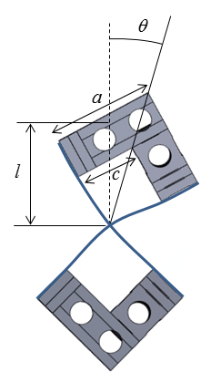

Figure 3: Math model for cartwheel flexure



 is the off axis second moment of mass,  is the second moment of mass of the top block to which the leafs are attached, is the mass of the block, is the half length of the leaf, and  are the dimensions of the block.

Kinetic energy, 

Potential energy, 

 and  are angular displacement and rate of angular displacement respectively.

Stiffness of the leaf spring, 

is the young’s modulus (303 stainless steel[2]), and are the width and thickness of the leaf

Natural frequency, 

An FRF analysis using a dynamic signal analyzer will be performed to arrive at experimentally derived transfer functions for both axes of the mechanical system.

# Error Budget

## Knife edge sensor

Any machine error that is constant in time when the machine is being used does not affect the performance with respect to the objective of the competition, as the control algorithm will compensate for it. This means that the driving error source in our machine design is the error in the sensors, due to factors such as resolution, drift, nonlinearity, etc. For example, the error in the knife edge sensor calibration curve (Figure 4), over a usable range of 350 micrometers, is . This number is arrived at by taking fitting a 1st-order polynomial to the calibration curve [3], taking the residual, and finding the standard deviation of the residual. The error is primarily attributable to the nonlinearity of the knife edge sensor at the edges of its usable range.

Figure 4: Linear portion of the calibration curve

## Gyroscope

Uncertainty at the target due to the pitch and yaw measurement errors are  and respectively. These values are arrived by implementing a moving average filter  to the angular velocity data recorded (for 10 minutes, Figure 5) from the static gyroscope and then integrating the averaged value.

Figure 5: Uncertainty due to Gyroscope

## Thermal expansion of the system

Position error due to thermal expansion of the flexure is calculated using a lumped parameter model, where the physical characteristics of the flexure assembly that would most negatively affect position accuracy were used as parameters.

Change in length of the mech block is .

is the thermal expansion coefficient for steel, is the length of the mech block attached to the voice coil, is the change in temperature with time

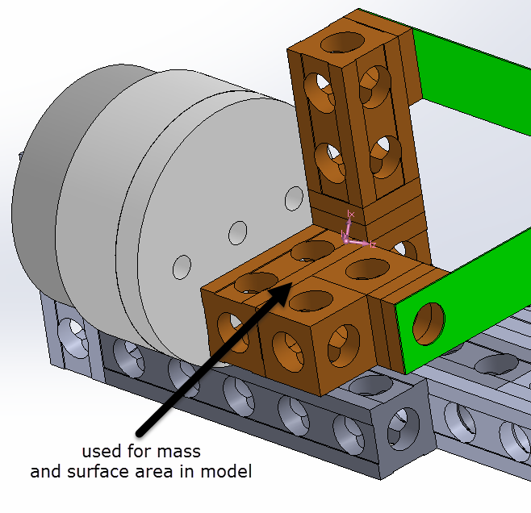

Figure 6: Thermal expansion of the mech block

Using the model,  [5]

 is the specific heat of steel,  is the heat transfer coefficient, is the surface area of the mech block,  is the power of the voice coil, is the temperature, is the temperature at infinity.

a temperature change of approximately  is estimated, giving an error due to thermal expansion of the flexure on the order of  .

Including the steel flexure strip in this analysis would increase the conservatism of the model.

Another uncertainty that would influence the target positioning would be the refractive index through which the laser beam traverses.

Combined uncertainty of the system is 

# Control Strategy

Angular velocity of the vibrating table will be read by the gyroscope in the IMU (MPU9250). The angular displacements calculated by integrating the gyroscope values will be provided as an input to the control structure. To maintain the laser on target, a PID controller C(s) will counter act these displacements by using the feedbacks provided by the knife edge sensors (RPI0352E). Due to the small angle approximation, linear displacement of the cartwheels measured by the knife edge sensor will be very close to the angular displacement. The controller is designed with an assumption that the translation of the table will be negligible as the distance to the target do not influence it.



Figure 7: Control structure

**Bill of Materials [see the attached excel file]**

No materials that are not provided in the standard kit are required to execute our design.

**References**

[1] Stuart T. Smith, Flexures, 2000

[2] <https://www.ezlok.com/technical-info/mechanical-properties/303-stainless-steel>

[3] 2017_Student_challenge_hardware.xlsx

[4] <http://www.balseal.com/sites/default/files/tr18_020707131421.pdf>

[5] Davies, Schmitz, Systems dynamics for mechanical engineers, 2015, pg. 301